# AWS

Before cloud computing every organisation has, they own assets (visual machine etc) which manages by visualization team by working with DCOPS team

# Cloud computing:

They are two types:

1. Private – it is for the organizations (big company)
2. Public - it is for the public

* Aws
* Azure
* Google cloud

# **What is cloud computing?**

Cloud computing is the on-demand delivery of IT resources over the Internet with pay-as-you-go pricing. Instead of buying, owning, and maintaining physical data centers and servers, you can access technology services, such as computing power, storage, and databases, on an as-needed basis from a cloud provider like Amazon Web Services (AWS).

Benefits of cloud computing:

1. Agility 🡪 quick start of cloud computing.
2. Elasticity
3. Cost saving
4. Deploying globally in minutes

# **Types of cloud computing**

The three main types of cloud computing include Infrastructure as a Service, Platform as a Service, and Software as a Service. Each type of cloud computing provides different levels of control, flexibility, and management so that you can select the right set of services for your needs.

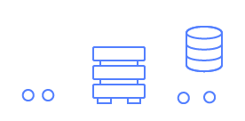

## **Infrastructure as a Service (IaaS)**

IaaS contains the basic building blocks for cloud IT. It typically provides access to networking features, computers (virtual or on dedicated hardware), and data storage space. IaaS gives you the highest level of flexibility and management control over your IT resources. It is most similar to the existing IT resources with which many IT departments and developers are familiar.

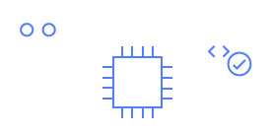

## **Platform as a Service (PaaS)**

PaaS removes the need for you to manage underlying infrastructure (usually hardware and operating systems), and allows you to focus on the deployment and management of your applications. This helps you be more efficient as you don’t need to worry about resource procurement, capacity planning, software maintenance, patching, or any of the other undifferentiated heavy lifting involved in running your application.



## **Software as a Service (SaaS)**

SaaS provides you with a complete product that is run and managed by the service provider. In most cases, people referring to SaaS are referring to end-user applications (such as web-based email). With a SaaS offering, you don’t have to think about how the service is maintained or how the underlying infrastructure is managed. You only need to think about how you will use that particular software.

# AWS Infrastructure

### Region

Availability zones—inside many data centers.

<https://aws.amazon.com/about-aws/global-infrastructure/?p=ngi&loc=0>

at now 32 regions 102 availability zone

region inside( 2 or more availability zones inside (many data centers)))

AWS has over 200 fully featured services for a wide range of technologies, industries, and use cases.

In devops:

Compute , storage, database, transfer, network, developer tools, manage and governances, secops services

# EC2

## EC2 Features

EC2 provides web services API for provisioning, managing, and deprovisioning virtual servers inside amazon cloud.

➢ Ease In Scaling Up/Down

➢ Pay only for what you use

➢ Can be integrated into several other services

## Ec2 Pricing

* On Demand Pay per hour or seconds.
* Spot Bid your price for unused ec2 capacity.
* Reserved Reserve Capacity(1 or 3 yrs) for discounts.
* Dedicated Hosts Physical Server dedicated for you.

AMI: Amazon Machine Image (AMI) provides the information required to launch an instance, which is a virtual server in the cloud.

INSTACES TPYES: When you launch an instance, the instance type that you specify determines the hardware of the host computer used for your instance

EBS: amazon elastic bock store(EBS) Amazon EC2 provides you with flexible, cost effective, and easy-to-use data storage options for your instances.

Tag :Tag is a simple label consisting of a customer-defined key and an optional value that can make it easier to manage, search for, and filter resources.

security group: A security group acts as a virtual firewall that controls the traffic for one or more instances

public–key: Amazon EC2 uses public–key cryptography to encrypt and decrypt login information.

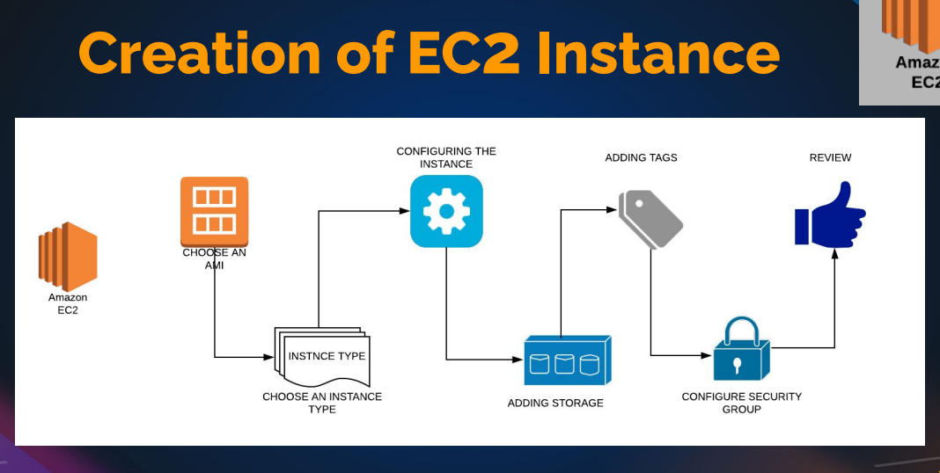

* Hand-on: go to ec2 instances and create a instances in free tiar and create key-pair(ssh, http) and create security group .

Do the proper Tags

Change/give the instances name and description

Add the security group

Check the network interface

* Do the provision step startbootstap and launch the website
* Launch website using both ssh and public Ip
* Create a elastic Ip and use it (it will get some cost)
* Action 🡪 change instances type ---> to increase /decrease the site of the instances
* Check the system log ----> in monitor & networking

To check the open ports : ss -tunlp | grep 80

8080 is Apache port number to assign it

# EC2 INSTANCES CRATION

Gathering information

1. Key pairs

2. Security Group

3. Instance Launch

sudo apt update

sudo apt install apache2 wget unzip -y

wget https://www.tooplate.com/zip-templates/2128_tween_agency.zip

unzip 2128_tween_agency.zip

sudo cp -r 2128_tween_agency/* /var/www/html/

sudo systemctl restart apache2

# Gathering information

Toolplate website

2. OS a. Centos

3. Size => Ram, CPU, Network etc a. Min

4. Storage size a.

5 gigs for web server images

5. Project

6. Services/Apps Running a. SSH, Http, Mysql etc

7. Environment (Dev, QA, Staging, Prod) 8. Login User/ Owner

## Link : https://docs.aws.amazon.com/AWSEC2/latest/UserGuide/ec2-security-groups.html

### Best Practices for Launching an EC2 Instance

#### 1. **Requirement Gathering**

* **Operating System**: Determine the OS you will use (e.g., Ubuntu, CentOS).
* **Instance Size**: Identify required CPU, RAM, and network speed.
* **Storage**: Specify the required storage space for the OS and applications.
* **Services**: List the services and applications that will run on the instance (e.g., SSH, HTTP, MySQL).
* **Environment**: Define whether it’s for development, staging, or production.
* **Login User and Ownership**: Identify the users who will log in and the owner for tagging purposes.

#### 2. **Creating a Key Pair**

* Create a key pair before launching the instance to ensure secure access.
* Use a naming convention that reflects the project and environment, e.g., **twin-dev-region**.

#### 3. **Setting Up Security Groups**

* Security groups act as virtual firewalls to control inbound and outbound traffic.
* Avoid opening all ports to all IPs; instead, specify necessary ports and IP ranges.
* For SSH access, limit it to specific IP addresses.
* Add rules for HTTP (port 80) or HTTPS (port 443) as needed.

#### 4. **Launching the Instance**

* **Tags**: Use tags to organize and manage instances (e.g., name, project, environment, owner).
* **AMI Selection**: Choose the appropriate Amazon Machine Image (AMI) based on the OS requirement.
* **Instance Type**: Select the instance type according to your requirement (e.g., t2.micro for free tier).
* **Key Pair**: Select the previously created key pair for SSH access.
* **Security Group**: Apply the created security group with the appropriate rules.
* **Storage Configuration**: Configure storage as per requirements.
* **Advanced Details**: Skip additional provisioning during initial setup if not needed.

#### 5. **Connecting to the Instance**

* Use SSH to connect to the instance using the key pair.
* Verify the default username (e.g., **ubuntu** for Ubuntu instances).

#### 6. **Setting Up a Web Server**

* **Install Apache**: Set up Apache or your preferred web server.
* **Deploy Website**: Place website files in the web server's root directory (e.g., **/var/www/html**).
* **Verify Apache Service**: Ensure the Apache service is running.

#### 7. **Testing Website Access**

* Modify security group to allow HTTP traffic on port 80.
* Access the website using the instance's public IP address.

### Example Workflow

1. **Delete Existing Key Pair**:

aws ec2 delete-key-pair --key-name "previous-key"

Create a new key pair:

aws ec2 create-key-pair --key-name "twin-dev-region" --query "KeyMaterial" --output text > twin-dev-region.pem

**Create Security Group**:

aws ec2 create-security-group --group-name "twin-web-dev-sg" --description "Security group for twin web dev"

Add inbound rules:

aws ec2 authorize-security-group-ingress --group-name "twin-web-dev-sg" --protocol tcp --port 22 --cidr "your-ip-address/32"

aws ec2 authorize-security-group-ingress --group-name "twin-web-dev-sg" --protocol tcp --port 80 --cidr "0.0.0.0/0"

**Launch EC2 Instance**:

aws ec2 run-instances --image-id "ami-xxxxxxxx" --count 1 --instance-type "t2.micro" --key-name "twin-dev-region" --security-groups "twin-web-dev-sg" --tag-specifications 'ResourceType=instance,Tags=[{Key=Name,Value=web01},{Key=Project,Value=twin},{Key=Environment,Value=dev},{Key=Owner,Value=lead-devops}]'

**Connect to Instance**:

ssh -i "twin-dev-region.pem" ubuntu@<instance-public-ip>

**Set Up Apache and Deploy Website**:

sudo apt update

sudo apt install apache2

sudo systemctl start apache2

sudo systemctl enable apache2

1. **Verify Website**:
   * Access the website using the public IP: **http://<instance-public-ip>**

By following these steps, you ensure a secure, organized, and efficient process for launching and managing EC2 instances.

### Managing EC2 Instances and Elastic IPs

#### **Powering Off and Restarting an Instance**

1. **Check IP Addresses**:
   * Note the public and private IP addresses of the instance.
2. **Stopping the Instance**:
   * Stop the instance. The public IP will be released, but the private IP will remain.
3. **Restarting the Instance**:
   * When you restart the instance, it will get a new public IP. The private IP remains unchanged.

#### **Using Elastic IPs**

1. **Allocating an Elastic IP**:
   * Allocate an Elastic IP from AWS. This IP is reserved for your use only.
2. **Associating Elastic IP**:
   * Associate the Elastic IP with your instance. This IP remains the same even after stopping and starting the instance.

#### **Benefits of Elastic IPs**

* **Static IP**: Remains unchanged across instance stops and starts.
* **Reusability**: Can be reassigned to different instances as needed.

#### **Network Interfaces**

* Security groups, public IPs, and private IPs are associated with network interfaces.
* Multiple network interfaces can be attached to an instance for more complex networking setups.

#### **Managing Instances**

1. **Changing Instance Type**:
   * **Stopping the Instance**: Required before changing the instance type.
   * **Change Type**: Select a new instance type and apply changes.
   * **Starting the Instance**: The instance will start with the new instance type.
2. **Networking Options**:
   * **Attach/Detach Network Interfaces**: Manage additional network interfaces.
   * **Disassociate Elastic IP**: Disassociate the Elastic IP if no longer needed.
   * **Change Security Groups**: Modify or assign additional security groups.
3. **Instance Settings**:
   * **Modify IAM Role**: Assign or modify IAM roles for the instance.
   * **Create Image**: Create an AMI from your instance for future use.
   * **Launch More Like This**: Create similar instances with the same settings.
4. **Monitoring and Troubleshooting**:
   * **System Logs**: Access boot and system logs for troubleshooting.

#### **Cleaning Up Resources**

1. **Terminate the Instance**:
   * **Terminate**: Completely remove the instance and release resources.
   * **Release Elastic IP**: Release the Elastic IP back to the AWS pool to avoid charges.
2. **Check Dashboard**:
   * Ensure there are no running instances, volumes, or elastic IPs remaining to avoid unnecessary charges.

#### **Key Practices**

* **Frequent Cleanup**: Regularly terminate and release resources not in use.
* **Resource Tags**: Use tags to manage and identify resources efficiently.
* **Stay Within Free Tier**: Use T2 or T3 micro instances for experiments to avoid charges.
* **Security**: Keep security groups limited to necessary ports and IPs for better security.
* **Elastic IPs**: Use only when static IP is needed; otherwise, release to avoid charges.

By following these steps and best practices, you can effectively manage EC2 instances and associated resources, ensuring efficient and secure use of AWS infrastructure.

# Aws cli

IAM 🡪 user 🡪 add user 🡪 in security credentials 🡪Access key(cli)

## Some commands

Aws configure

Aws –version

Aws sts get-caller-identity

Aws ec2 describe-instances

Etc

<https://aws.amazon.com/cli/>

to check commands

and follow the command line interface pdf in devops learning

## link : <https://awscli.amazonaws.com/v2/documentation/api/latest/index.html>

<https://docs.aws.amazon.com/cli/latest/userguide/getting-started-install.html>

# EBS -ELASTIC BLOCK STORAGE

* Block based storage

★ Runs ec2 OS, store data from db, file data, etc

★ Placed in specific AZ. Automatically replicated within the AZ to protect from failure.

★ Snapshot is backup of a volume

## EBS Types

● General Purpose (SSD) ○ Most Work Loads

● Provisioned IOPS ○ Large Databases

● Throughput Optimized HD ○ Big Data & Data Warehouses

● Cold HDD ○ File Servers

● Magnetic ○ Backups & Archives

<https://docs.aws.amazon.com/AWSEC2/latest/UserGuide/AmazonEBS.html>

or ebs volume types

## volumes

instances 🡪 storage 🡪 volume 🡪 click and rename the volume (both instances and volume should be in the same AZ (Availability zone)

exercise:

Size => Ram, CPU, Network etc

Min

4. Storage size

5 gigs for web server images

In the 30 gb you are in free trie

* Create a volume(make sure instances and volume should be same AZ) 🡪 attach the volume to the exiting once in the (actions 🡪 attach)

Partition:

Partition web images only :

Cd /var/www/html/images/

fdisk -l

fdisk /dev/xvdf

help -n

-a for partition

-1

+3g

Click enter

mkfs (double tab)

mkfs -ext4 /dev/xvdf **# formating**

mount & umount

take a back-up of images : mkdir /tmp/backup-imgs

mv /var/www/html/images/* /tmp/backup-imgs/

mount /dev/xvdf /var/www/html/images/

**# mount filesystem path**

df -h (to check mounted or not

umount /var/www/html/images/

**# umount path**

**this is tempory mount**

**to do permanently**

* Vi /etc/fstab

Add the line

/dev/xvdf /var/www/html/images/ ext4 defaults 0 0

# **( 0 – no dump, 0 – file system sfc code)**

Mount -a

mv /tmp/backup-imgs/* /var/www/html/images/

if still website is not working then use

vi /etc/selinux/cofig

* disable selinux

reboot the machine

short note

check

df -h (list to filesystem to mounted)

fdisk -l (list of disks)

mkfs -🡪 format for files(file type)

add the volume🡪 make new partition(fdisk xvdf) 🡪 mkfs (files format 🡪 do mount 🡪 check the mount status

🡪it temporary

* to make permanent 🡪 vi /etc/fstab 🡪 add the line dev/xvdf1 /var/www/html ext4 defaults 00

# **filesystem** path to mount **file-format defaults 0 0**

# Snapshot Backup & Restore

* Unmount partition

• Detach volume

• Create new volume from snapshot

• Attach the volume created from snapshot

• Mount it back

Snapshot :

Create a snapshot from exiting volume(like for backup&restore), if you remove the file or corrupt the file then we can replace the new volume by using snapshot

* Umount the exiting volume🡪 detach the volume🡪 create a new volume from snapshot(action)🡪attach the new volume 🡪 mount it again (mount -a)
* Snapshot can be used for exception , increase the volume , change the type of the volume , image , copy from one region to other region etc

If you need to delate the volume

* Detach the volume 🡪delate the volume

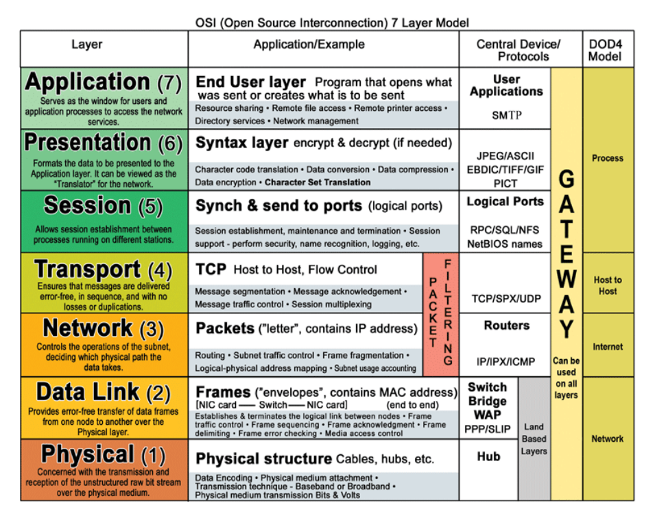

**Application(Layer 7)** This layer supports application and end-user processes. Communication partners are identified, quality of service is identified, user authentication and privacy are considered, and any constraints on data syntax are identified. Everything at this layer is application-specific. This layer provides application services for file transfers, e-mail, and other network software services.  
  
**Presentation(Layer 6)** This layer provides independence from differences in data representation (e.g., encryption) by translating from application to network format, and vice versa. This layer formats and encrypts data to be sent across a network, providing freedom from compatibility problems. It is sometimes called the syntax layer.  
  
**Session(Layer 5)** This layer establishes, manages and terminates connections between applications. The session layer sets up, coordinates, and terminates conversations, exchanges, and dialogues between the applications at each end. It deals with session and connection coordination.  
  
**Transport(Layer 4)**This layer provides transparent transfer of data between end systems, or hosts, and is responsible for end-to-end error recovery and flow control. It ensures complete data transfer.  
  
**Network(Layer 3)** This layer provides switching and routing technologies, creating logical paths, known as virtual circuits, for transmitting data from node to node. Routing and forwarding are functions of this layer, as well as addressing, internetworking, error handling, congestion control and packet sequencing.  
  
**Data Link(Layer 2)** At this layer, data packets are encoded and decoded into bits. It furnishes transmission protocol knowledge and management and handles errors in the physical layer, flow control and frame synchronization. The data link layer is divided into two sublayers: The Media Access Control (MAC) layer and the Logical Link Control (LLC) layer. The MAC sublayer controls how a computer on the network gains access to the data and permission to transmit it. The LLC layer controls frame synchronization, flow control and error checking.  
  
**Physical(Layer 1)** This layer conveys the bit stream - electrical impulse, light or radio signal -- through the network at the electrical and mechanical level. It provides the hardware means of sending and receiving data on a carrier, including defining cables, cards and physical aspects.

**OSI Layer Model for concentrators**

**Hubs/Repeaters** are found in the **Physical Layer**  
  
**Switches /Bridges/Wireless Access Point**are found in the **Data Link Layer**

**Multilayer Switch** are found in both the **Data Link Layer and Network Layer**  
  
**Routers** are found in the**Network Layer**  
  
**Gateway** are found in **All 7 of the OSI Layers**

**Brouter** are found in both the **Data Link** and **Network Layer**

|  |
| --- |
| [**OSI**](http://en.wikipedia.org/wiki/OSI_model)**OSI 7 Layer Model** |
| **7. Application Layer**- DHCP, DNS, FTP, HTTP, IMAP4, NNTP, POP3, SMTP, SNMP, SSH, TELNET and NTP[more)](http://en.wikipedia.org/wiki/Category:Application_layer_protocols) |
| **6.** **Presentation layer** – SSL, WEP, WPA, Kerberos, |
| **5. Session layer** – Logical Ports 21, 22, 23, 80 etc… |
| **4. Transport -**TCP, SPX and UDP[more)](http://en.wikipedia.org/wiki/Category:Transport_layer_protocols) |
| **3. Network -** IPv4, IPV6, IPX, OSPF, ICMP, IGMP and ARP[MP](http://en.wikipedia.org/wiki/Internet_Group_Management_Protocol) |
| **2. Data Link-**802.11 (WLAN), Wi-Fi, WiMAX, ATM, Ethernet, Token Ring, Frame Relay, PPTP, L2TP and ISDN[-](http://en.wikipedia.org/wiki/Wi-Fi)[ore)](http://en.wikipedia.org/wiki/Category:Link_protocols) |
| **1. Physical-**Hubs, Repeaters, Cables, Optical Fiber, SONET/SDN,Coaxial Cable, Twisted Pair Cable and Connectors [(more)](http://en.wikipedia.org/wiki/Category:Physical_layer_protocols) |

# Clusters

● Cluster of servers needs Endpoints

● Endpoints are usually of a Load Balancer

● Load Balancer balances incoming traffic to backend servers

## LOAD BALANCER Ports

* Frontend Port: Listens from the User Requests on this port AKA Listeners.
* e:g 80, 443, 25 etc
* Backend Ports: Services running on OS listening on this port
* e:g 80, 443, 8080 etc

ELASTIC LOAD BALANCER

● Elastic Load Balancing distributes incoming application or network traffic across multiple targets, such as Amazon EC2 instances, containers, and IP addresses, in multiple Availability Zones.

● Elastic Load Balancing supports three types of load balancers:

* Application Load Balancer
* Network Load Balancer
* Classic Load Balancer
* Gateway Load Balance

# CLASSIC LOAD BALANCER

● The Classic Load Balancer that routes traffic based on either application or network level information

● The Classic Load Balancer is ideal for simple load balancing of traffic across multiple EC2 instance

# APPLICATION LOAD BALANCER

● Application Load Balancer that routes traffic based on advanced application level information that includes the content of the request

## NETWORK LOAD BALANCER

● A Network Load Balancer functions at the fourth layer of the Open Systems Interconnection (OSI) model.

● It can handle millions of requests per second.

● Static IP

# Refer awssides in devops learning

# ELB HANDS-ON

Create a instances with amazon – linux with provision tooplate template website 🡪 create a AMI(from the instances)[ instances🡪action🡪image and templates🡪 create image]

**“snapshot we can create a volume”**

**“AMI we can create an instance” AMI equlent shapshot + matadata**

* We can launch the instances from the AMI

OR

We can create a launch template from template, we can create a same type of instances very quickly

ELB: importance’s

Now we have two instances with blog website, they cannot be access separately by user,

They can be accessing the website from the single endpoint that can be done by the load balances

Load balances: goto target group

[ **target group is basically a group of instances, with health . checks** (it checks the website health by loading again and again upto the value we given, if it all loaded good then it is health]

* Create a load balances (application load balances) with instances and create a security group and add the target group and check the option again launch it)

🡪Once load balance in active copy the DNS name and check the website is working or not. If not, check the security group (if you using different sg’s for the instance the pass the elb-sg in sg (sg- security group)

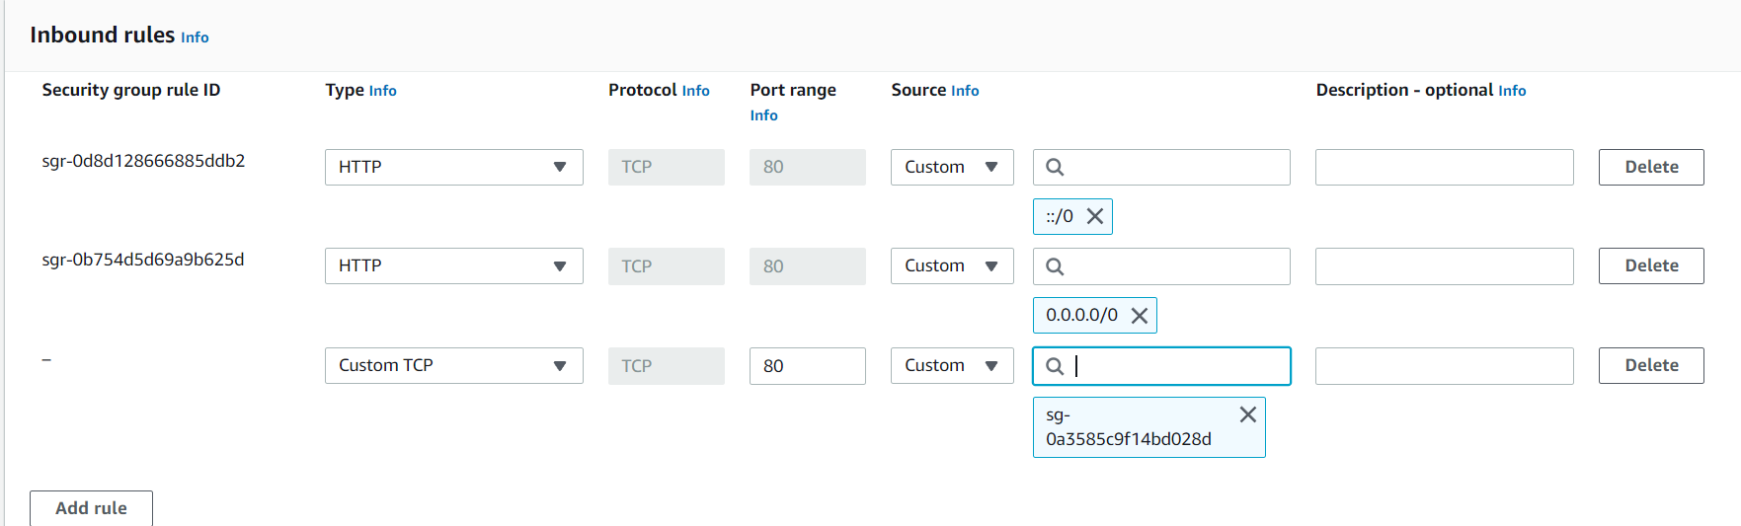

In target group(tg) we can register or deregister the tg 🡪(deregister is help to stop the traffic on maintance work)

# Cloud watch

Cloud Watch - Monitor performance of AWS environment - standard infrastructure metrics.

● Metrics: AWS cloud watch allows. you to record metrics for services such as EBS, EC2, ELB, Route53 Health checks, RDS, Amazon S3, cloudfront etc etc…

● Events: AWS Events delivers a near real-time stream of system events that describe changes in Amazon Web Services (AWS) resources

● Logs: You can use Amazon CloudWatch Logs to monitor, store, and access your log files from Amazon Elastic Compute Cloud (Amazon EC2) instances, AWS CloudTrail, Route 53, and other sources

* Alarm monitors CloudWatch metrics for Instances.
* Simple Notification Service (Amazon SNS) is a web service that coordinates and manages the delivery or sending of messages to subscribing endpoints or clients.

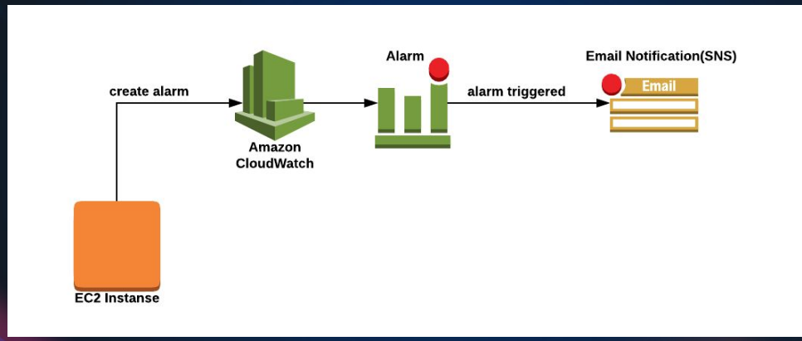

In instance🡪monitor(can see the metrics logs)

Normally/default cloud watch will monitor the metrics every five minutes (but can customize the time but some cost will applicable)

Instances🡪monitor🡪managing &detail monitor🡪can change the time here

* Launch the instance🡪 install the stress🡪 check the monitor graft

Yum install stress -y

Stress

Stress -c 4 (to stress the cpu 4 proess)

nohup stress -c 4 -t 300 &

Top (to check the all utilization)

Script

Script.sh

Sleep 60 & stress -c 4 -t 60 & Sleep 30 & stress -c 4 -t 60 &

Sleep 60 & stress -c 4 -t 500 & Sleep 60 & stress -c 4 -t 30 &

Nohup ./script.sh &

Cloudwatch🡪alarm🡪create alarm🡪select metrics🡪browse🡪ec2🡪 cpu-unitization🡪create topic🡪set alarm (name : warning | high cpu untilztion )

Some other alarm tools : promethus, nagios, icinga, zenos..etc

# EFS – ELASTIC FILE SYSTEM

* + 1. 🡪 create a security group 🡪 NFS (NETWORK FILE SYSTEM) -type
    2. 🡪 CREATE EFS
    3. 🡪 access point
    4. 🡪 install efs file
* Amazon linux

sudo yum install -y amazon-efs-utils

* Utuntu

$ sudo apt-get update

$ sudo apt-get -y install git binutils rustc cargo pkg-config libssl-dev

$ git clone https://github.com/aws/efs-utils

$ cd efs-utils

$ ./build-deb.sh

$ sudo apt-get -y install ./build/amazon-efs-utils*deb

https://aws.amazon.com/efs

EFS – is a shared storage on aws (shared file system over the network)

* Create a instance 🡪 create a security group (efs-blog-sg) 🡪 create a EFS file system 🡪 create a access point
* To mount the EFS file system using this link :
* <https://docs.aws.amazon.com/efs/latest/ug/wt1-test.html>

to install amzon-efs-ulity is easily in amazon linux

sudo yum install -y amazon-efs-utils

**#please check the doc for more details**

# Using the EFS mount helper to automatically re-mount EFS file systems

file-system-id:/ efs-mount-point efs _netdev,noresvport,tls,iam,accesspoint=access-point-id 0 0

fs-47a77ccb /var/www/html/img efs _netdev,noresvport,tls,iam,accesspoint=fsan-03f6334520365d3 0 0

* Take a backup of images

Mkdir /tmp/backup-img

Mv /var/www/html/img/* /tmp/backup-img

Vi /etc/fstab

fs-47a77ccb /var/www/html/img efs _netdev,noresvport,tls,iam,accesspoint=fsan-03f6334520365d3 0 0

mount -fav

Mv /tmp/backup-img/* /var/www/html/img/

Df -h

# AUTO SCALING

* Auto Scaling is a service that automatically monitors and adjusts compute resources to maintain performance for applications hosted in the AWS.
* Alarm monitors CloudWatch metrics for Instances
* A launch configuration/Template is an instance configuration template that an Auto Scaling group uses to launch EC2 instances
* Scaling policy is used to increase and decrease the number of running instances in the group dynamically to meet changing conditions.

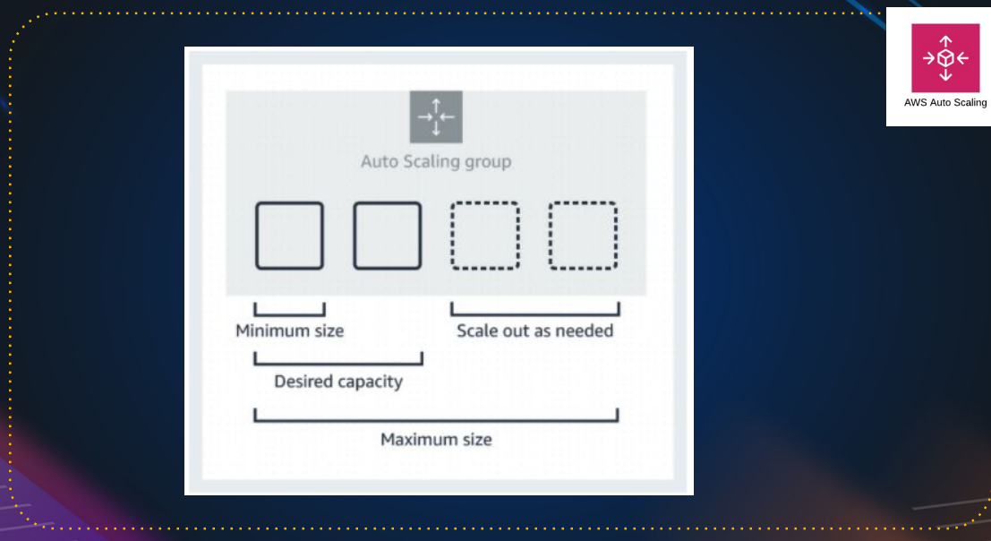

Example:

Minimum size: 1 instance #we can’t remove it

Desired capacity: 2 instances #it will create 2 instances on auto scaling

Maximum size: 4 instances #ASG can create max of 4 instances

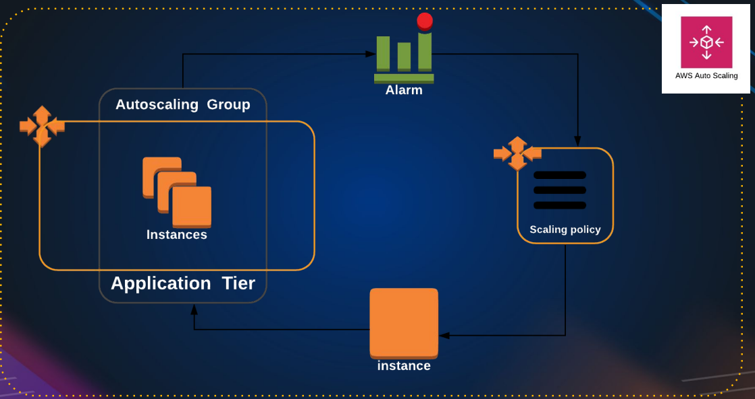

Hands-on: create a lunch template🡪 set the target group(if it empty also no-issues ASG will assign automatically)🡪create a ASG🡪

Launch template: we can edit

Launch configurations: we can’t edit it

it

In Health check : ec2 health check by default it will do hardware health check and vm health check

ELB health check “ target group checks every 30 seconds, if instance is unhealth it will declare as unhealth, means basically it checking the port number or process whether it’s up or not.

If instance is health, target group will declare as health. If tg declare is not health then ASG remove the unhealth instance and create a new instance automatically.

Note:

If you update manually in instance, then after sometime instance get deleted and it will launch instance with OLD AMI, so always create a new launch template and edit the launch template in ASG and update they

ASG🡪 select the ASG🡪 details🡪edit the launch template and update the new launch template over there 🡪 start instances refresh in **instances refresh**

Important

ASG is dynamic instances, make sure they do not store any information.

The storage should be out of this easy instance, like on EFS OR NFS, somewhere out

### Ingredients Needed:

1. **Launch Template**: Ensure you have the launch template from the load balancer section. If not, recreate it.
2. **Load Balancer**: Necessary for distributing traffic across instances.

### Steps to Set Up Auto Scaling Group:

1. **Create a Target Group**:
   * Go to Target Groups and create a new one named **health-TG**.
   * Set it up as you did in the load balancer section.
   * Leave it empty; the Auto Scaling Group will add instances to it later.
2. **Create a Load Balancer**:
   * Create a new Application Load Balancer named **health-elb**.
   * Use the same security groups as before, except for the default security group.
   * Link it to the target group **health-TG**.
3. **Set Up Auto Scaling Group**:
   * Name it **healthy-ASG**.
   * Select the previously created launch template.
   * Choose the availability zones for the instances.
   * Attach the Auto Scaling Group to the existing load balancer and target group.
4. **Configure Health Checks**:
   * Enable ELB (Elastic Load Balancer) health checks for more accurate health status of instances.
   * EC2 health checks are basic and may not detect issues with the application running on the instances.
5. **Define Capacity Settings**:
   * Desired Capacity: 2 instances.
   * Minimum Capacity: 1 instance.
   * Maximum Capacity: 8 instances.
   * This ensures you always have at least one instance running and no more than eight.
6. **Set Scaling Policies**:
   * Use target tracking scaling policy based on CPU utilization (e.g., add instances if CPU > 50%, remove if CPU < 50%).
   * Adjust settings according to your needs.
7. **Review and Create**:
   * Add any necessary notifications.
   * Tag the instances (e.g., **Name: web-server**).
   * Review settings and create the Auto Scaling Group.

### Post-Creation:

* **Monitor Instances**: Check the instances created by the Auto Scaling Group in the Instances section.
* **Target Group Update**: Ensure the new instances are added to the target group and are healthy.

### Important Considerations:

* **Dynamic Instances**: Avoid manual changes to instances as they can be terminated and recreated based on the launch template.
* **Launch Template Changes**: For any updates, modify the launch template or create new versions, then refresh instances in the Auto Scaling Group.
* **Logging and Storage**: Ensure logs and dynamic data are stored outside the instances (e.g., using EFS or NFS).

### Cleanup:

* **Delete Auto Scaling Group**: This will automatically terminate the associated instances.
* **Delete Load Balancer**: Clean up resources to avoid unnecessary charges.

### Summary:

This session covered setting up an Auto Scaling Group with a load balancer and target group, defining health checks, and configuring scaling policies. It emphasized the importance of using the launch template for changes and storing dynamic data outside the instances. Finally, it included steps for cleaning up the resources after the setup.

# S3- Simple Storage Service

(it is like a google drive & drop box but much more feature)

Amazon Simple Storage Service (Amazon S3) is storage for the internet. You can use Amazon S3 to store and retrieve any amount of data at any time, from anywhere on the web.

## S3 Basics

* It is Object-Based Storage
* Data is replicated across multiple facilities
* Unlimited Storage
* Amazon S3 stores data as objects within buckets
* Bucket name has to be unique

#Because you will be getting end point to access it and then end point will have the name of the bucket, so it has to be unique in the internet

Bucket: A bucket is a logical unit of storage in Amazon Web Services (AWS).

Object: Object Storage is a computer data storage architecture that manages data as Objects.

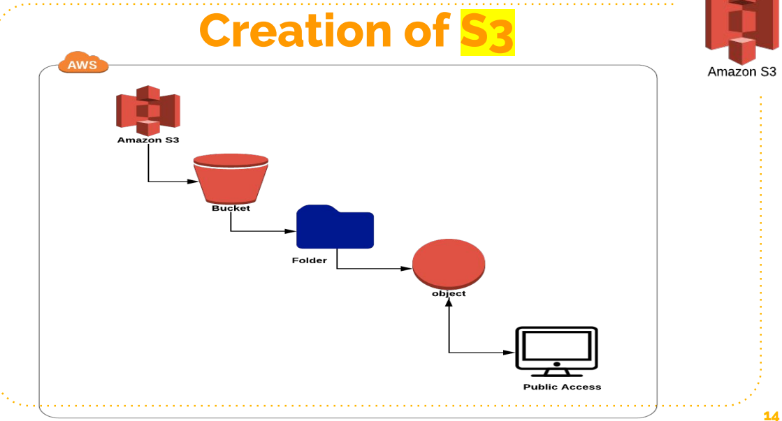

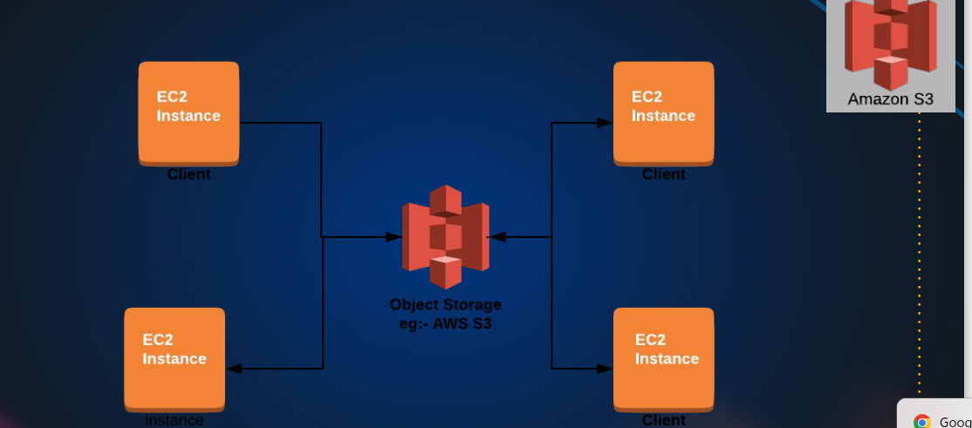

It seems like EFS through this architectural design, but in EFS we mount the filesystem at the operating system level.so we get a folder at the operating system layer, level, where we store the data

But S3 we are going programmatically access through our application.

We can also mount s3 bucket to a folder but that comes though a different driver S3FS

# S3 Storage Classes

1. S3 Standard: general-purpose storage of frequently accessed data. Fast access & object replication in multi-AZ.
2. S3 IA– Infrequent Access: Long-lived, but less frequently accessed data. Slow access, object replication in multi-AZ.
3. S3 One Zone-IA is for data that is accessed less frequently, but requires rapid access when needed. Slow access, no object replication.
4. S3 Intelligent Tiering Automatically moves data to most cost effective tier.
5. S3 Glacier: Low Cost Storage class for data Archiving.
6. S3 Glacier Deep Archive Lowest cost storage, retrieval time of 12 Hrs.

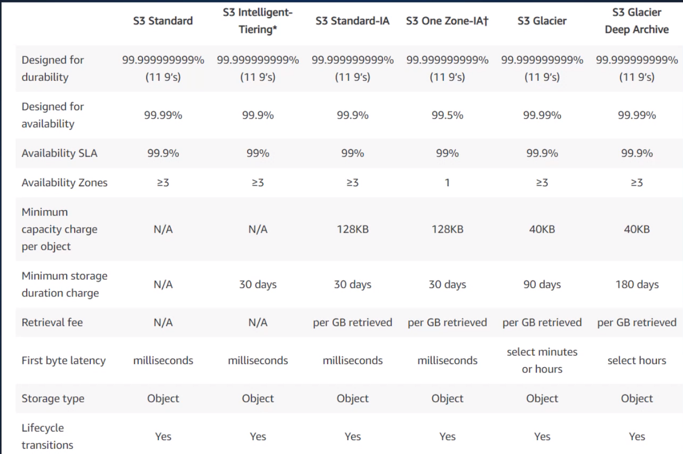

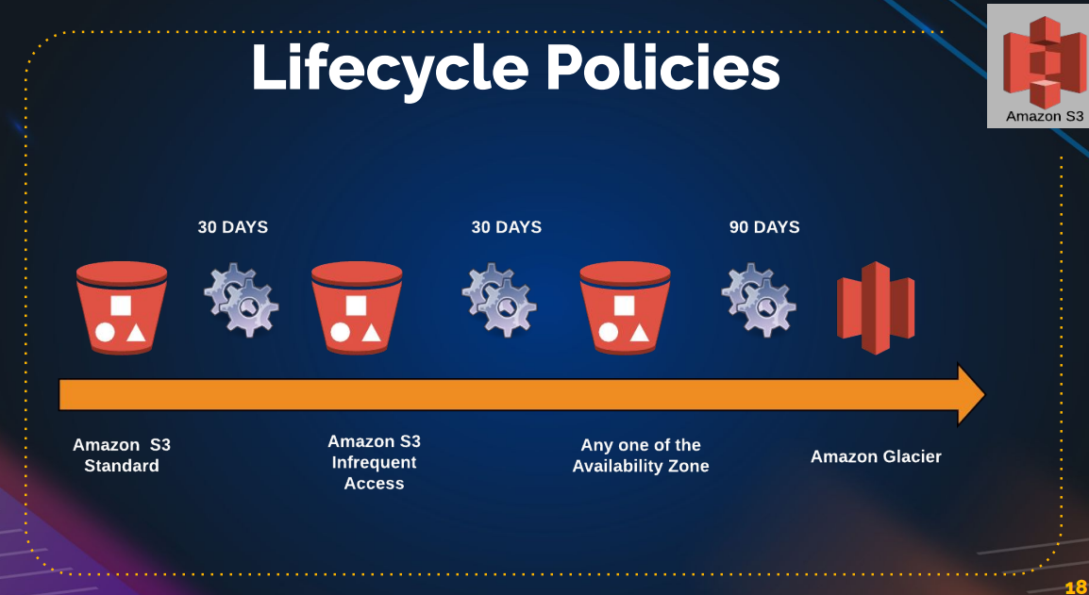

**This to save the cost** ,

we are applying the lifecycle policy, usually on log’s archive and you can also set expiry, also you can set after sometime(1year or two years) delete this data.

## Amazon S3 Session Overview

### Introduction to Amazon S3

* **What is Amazon S3?**
  + Amazon Simple Storage Service (S3) is an internet-accessible storage service.
  + Similar to Google Drive or Dropbox but with more features.
  + Allows storing and accessing any amount of data from anywhere.
  + Popular and one of the oldest AWS services.

### Basic Concepts of S3

* **Object Storage:**
  + S3 is an object storage service.
  + Data is stored as objects within buckets (similar to folders).
  + Objects can be documents, pictures, videos, etc.
  + Buckets must have unique names globally.
* **Data Replication and Durability:**
  + Data in S3 buckets is replicated across multiple facilities for durability.
  + S3 offers virtually unlimited storage capacity.

### Bucket and Object Management

* **Buckets:**
  + Logical containers for storing objects.
  + Can set permissions and properties at the bucket level.
* **Objects:**
  + Individual data items stored in buckets.
  + Can set permissions and properties at the object level.

### Access and Permissions

* **Access Control:**
  + Access can be managed through IAM policies, bucket policies, and ACLs.
  + By default, all objects are private.
  + Public access must be explicitly enabled.

### Common Use Cases

* **Integration with EC2:**
  + EC2 instances can store file-based data in S3 rather than locally.
  + Useful for applications requiring storage of web service data, etc.

### Storage Classes

1. **S3 Standard:**
   * High availability and durability.
   * Fast data access and replication across multiple availability zones.
2. **S3 Infrequent Access (IA):**
   * Lower cost for less frequently accessed data.
   * Slower access compared to Standard but still replicated across multiple availability zones.
3. **S3 One Zone IA:**
   * Lower cost for infrequently accessed data that doesn't require high durability.
   * Data stored in a single availability zone.
4. **S3 Intelligent Tiering:**
   * Automatically moves data to the most cost-effective access tier.
5. **S3 Glacier:**
   * Low-cost storage for data archiving.
   * Suitable for data accessed infrequently (e.g., once a year).
6. **S3 Glacier Deep Archive:**
   * Lowest-cost storage for long-term data archiving.
   * Data retrieval can take up to 12 hours.

### Lifecycle Policies

* **Lifecycle Policies:**
  + Automate transitioning of data between different storage classes.
  + Example: Move data to IA after 30 days, Glacier after 90 days, and delete after a year.

### S3 Charges

1. **Storage Charges:**
   * Based on the amount of data stored.
2. **Request Charges:**
   * Based on the number of requests made to S3.
3. **Data Transfer Charges:**
   * Charges for data transferred out of S3.
4. **Replication Charges:**
   * Additional charges for cross-region replication.

### Creating and Managing Buckets and Objects

#### Steps to Create an S3 Bucket and Upload Files:

1. **Create a Bucket:**
   * Open the AWS console and navigate to S3.
   * Click "Create bucket" and provide a unique name.
2. **Configure Bucket Settings:**
   * Enable or disable Object Ownership and ACLs.
   * Block public access by default for security.
   * Enable versioning and encryption if needed.
3. **Upload Objects:**
   * Select the bucket and click "Upload".
   * Choose files and configure storage class, permissions, and encryption.
4. **Manage Object Access:**
   * Objects are private by default.
   * To make objects public, adjust bucket permissions and enable public access through ACLs.

#### Making Objects Public:

1. **Enable ACLs:**
   * Go to bucket permissions and enable ACLs.
2. **Unblock Public Access:**
   * Edit the block public access settings and uncheck the blocking options.
3. **Set Object Permissions:**
   * Select objects and use actions to make them public.

### Practical Exercise

* **Create an S3 Bucket:**
  + Follow steps to create and configure the bucket.
* **Upload and Manage Objects:**
  + Upload files, check permissions, and try accessing them via URL.
  + Practice making objects public and understanding access controls.

### Next Steps

* **Hosting a Website on S3:**
  + In the next session, learn how to host a static website using S3.

By following this structure, you can efficiently navigate through the core aspects of Amazon S3, ensuring a clear understanding of its functionalities and practical applications.

# S3 Charges

* Storage
* Requests
* Tiers
* Data Transfer
* Region Replication

Some of the feature’s like **bucket versioning**: if you enable this data is overwrite or deleted , then is present there only then we can revive deleted once. But if we delete more then more storage is required

S3 object 🡪 delete the file(index.html)🡪 it will not delete(because versioning is enble) 🡪if you delete permanent the click the enable-icon on the left and select deleted files do permanent delete to remove the files

Use case: upload the date and access to from anywhere by making public. We can host to public

Create a S3 bucket 🡪 upload the data(code, files and artifacts etc) 🡪unblock the public serves 🡪 goto object🡪 make it public (to files/object) 🡪 use the object URL to access the object/name from anywhere

Exercise:

Launch the website from tooplate.com using s3 bucket

Move/upload all the files to S3 bucket 🡪 select all files and make as public 🡪 check the block permission if in block state 🡪 properties under bottom enable the static website hosting 🡪 get the end point URL and check the website is working or not.

# Lifecycle roles

[Amazon S3](https://s3.console.aws.amazon.com/s3/get-started?region=us-east-1) 🡪[Buckets](https://s3.console.aws.amazon.com/s3/buckets?region=us-east-1) 🡪[blog-storage-s3](https://s3.console.aws.amazon.com/s3/buckets/blog-storage-s3) 🡪[Lifecycle configuration](https://s3.console.aws.amazon.com/s3/management/blog-storage-s3/lifecycle?region=us-east-1) 🡪 **Create lifecycle rule**

**Set the roles for storage type to cost “refer the lifecycle policies**

## Replication

[Amazon S3](https://s3.console.aws.amazon.com/s3/get-started?region=us-east-1) 🡪 [Buckets](https://s3.console.aws.amazon.com/s3/buckets?region=us-east-1) 🡪[blog-storage-s3](https://s3.console.aws.amazon.com/s3/buckets/blog-storage-s3) 🡪[Replication rules](https://s3.console.aws.amazon.com/s3/management/blog-storage-s3/replication?region=us-east-1) 🡪 C**reate replication rule**

**“” UPTO 5GB S3 under free tair “”**

### Step-by-Step Guide to Hosting a Static Website on AWS S3

1. **Download and Extract Website Template**
   * Visit [Tooplate](https://www.tooplate.com/) or any other source for free website templates.
   * Download a template and extract the contents of the downloaded zip file to a folder.
2. **Create S3 Buckets**
   * Log in to the AWS Management Console.
   * Go to the S3 service.
   * **Create the main bucket for your website:**
     + Click on "Create bucket".
     + Name the bucket uniquely (e.g., **barista123**).
     + Enable versioning (can be enabled later if not done now).
     + Complete the creation process.
   * **Create a bucket for access logs:**
     + Click on "Create bucket".
     + Name it uniquely (e.g., **barista123-accesslogs**).
     + Ensure the name is in all lowercase.
     + Complete the creation process.
3. **Upload Website Files to S3 Bucket**
   * Open the main bucket (e.g., **barista123**).
   * Click on "Upload", then "Add files".
   * Drag and drop all the files from the extracted folder or use the file picker to upload.
   * Click "Upload".
4. **Make the Bucket Public**
   * Go to the bucket's permissions.
   * Edit the "Block public access" settings and uncheck the options to allow public access.
   * Save the changes and confirm.
   * Enable ACLs (Access Control Lists) if not already enabled.
5. **Make All Objects Public**
   * Select all objects in the bucket.
   * Choose "Actions" and then "Make public using ACL".
   * Confirm the warning and proceed.
6. **Enable Static Website Hosting**
   * Go to the bucket's properties.
   * Scroll down to "Static website hosting".
   * Edit the settings and enable static website hosting.
   * Set the index document (e.g., **index.html**) and error document (e.g., **error.html**).
   * Save the changes.
   * Note the website endpoint URL provided.
7. **Set Up Access Logs**
   * In the main bucket's properties, locate "Server access logging".
   * Edit the settings and enable access logs.
   * Specify the access log bucket (e.g., **barista123-accesslogs**).
   * Save the changes.
8. **Verify Website Access**
   * Open a web browser.
   * Enter the website endpoint URL provided in the static website hosting section.
   * Verify that the website loads correctly.
9. **Enable Versioning and Manage Versions**
   * In the main bucket’s properties, enable versioning if not already done.
   * To view versions, use the "Show versions" toggle in the S3 console.
   * Demonstrate adding a new version of a file by uploading a new **index.html**.
   * Make the new object public if necessary.
   * Use the versions view to delete and restore previous versions.
10. **Access Logs Verification**
    * The logs for access will appear in the access logs bucket.
    * These logs will provide details about who accessed the website, the browser used, regions, etc.
    * Check after some time as it might take a while for the logs to appear.

### Summary

Hosting a static website on AWS S3 is straightforward and eliminates the need for traditional web servers. By using S3's static website hosting capabilities, you can easily deploy and scale your website. Additionally, versioning helps manage changes, and access logs provide valuable insights into website traffic.

### Additional Notes

* **CNAME Configuration**: Later, you can configure a custom domain and set up CNAME records to point to the S3 website endpoint.
* **Cost Considerations**: Be mindful of the storage costs, especially with versioning enabled, as each version of a file is stored separately.

This guide captures the essence of the lecture and provides a clear, practical approach to hosting a static website on AWS S3.

### Advanced S3 Bucket Features: Lifecycle Rules and Disaster Recovery

In this lecture, we will explore advanced features of Amazon S3 buckets that help manage costs, comply with disaster recovery protocols, and optimize storage efficiency. These features are essential for DevOps engineers and architects to understand and implement effectively.

#### Lifecycle Rules for Cost Management

**Lifecycle Rules** allow you to define the transition of objects between different storage classes based on their age, helping to optimize storage costs.

1. **Access the Management Tab**

- Navigate to the S3 bucket.

- Click on the "Management" tab.

2. **Create a Lifecycle Rule**

- Click "Create lifecycle rule".

- Name the rule (e.g., `CostEffectiveTransitions`).

3. **Define the Scope**

- Apply the rule to all objects or limit it by specifying a prefix (e.g., files that start with "image").

4. **Set Transition Actions**

- **Current Version Objects:**

- Transition from `Standard` to `Standard-IA` after 30 days.

- Transition from `Standard-IA` to `One Zone-IA` after 60 days.

- Transition to `Glacier Flexible Retrieval` after 90 days.

- Transition to `Glacier Deep Archive` after 180 days.

- **Non-Current Version Objects:**

- Transition from `Standard` to `Standard-IA` after 35 days.

- Transition from `Standard-IA` to `One Zone-IA` after 65 days.

- Transition to `Glacier Flexible Retrieval` after 95 days.

- Transition to `Glacier Deep Archive` after 185 days.

5. **Expire Objects**

- Set expiration for objects (e.g., after 450 days).

6. **Delete Non-Current Versions**

- Set a rule to permanently delete non-current versions (e.g., after 455 days).

7. **Handle Incomplete Uploads**

- Delete incomplete uploads after a specified period (e.g., 15 days).

8. **Create the Rule**

- Click "Create rule" to apply it.

#### Disaster Recovery with Cross-Region Replication

To ensure data durability and compliance with disaster recovery protocols, configure cross-region replication.

1. **Create a Destination Bucket**

- In a different region (e.g., Oregon), create a new bucket (e.g., `barista908dr`).

2. **Set Up Replication**

- Go back to the source bucket.

- Click on "Management" and then "Create replication rule".

- Name the rule (e.g., `DisasterRecoveryBarista908`).

3. **Define the Replication Scope**

- Apply the rule to all objects or filter based on specific criteria.

4. **Choose Destination Bucket**

- Select the destination bucket created in the other region.

5. **Enable Versioning**

- Ensure versioning is enabled in the destination bucket.

6. **Configure IAM Role**

- Create a new IAM role to grant necessary permissions for replication.

7. **Set Destination Storage Class**

- Choose an appropriate storage class for the destination bucket (e.g., `Standard-IA` or `One Zone-IA`).

8. **Additional Options**

- Configure replication metrics, replication time control, and delete markers as needed.

9. **Save the Rule**

- Submit the rule to start replication for new objects.

#### Clean Up

1. **Delete Lifecycle and Replication Rules**

- Remove lifecycle and replication rules to avoid unintended costs.

2. **Delete Buckets**

- Empty and delete the created buckets to clean up resources.

### Summary

This lecture covered essential S3 features for cost management and disaster recovery. By using lifecycle rules, you can transition objects to cheaper storage classes based on their age. Cross-region replication ensures your data is resilient to regional failures, adhering to disaster recovery best practices. These advanced configurations are crucial for efficient and reliable data storage management in any AWS-based infrastructure.

### Next Steps

In the next lecture, we will delve into more advanced S3 features and AWS services, continuing to build your expertise as a DevOps engineer or architect. Be sure to clean up the resources used in this lecture to avoid unnecessary charges.

# Relational Database (RDB)

## DB Administration

* Installs
* Patching
* Monitoring
* Performance Tuning
* Backups
* Scaling
* Security
* Hardware upgrades
* Storage Management

## RDS

❖ Amazon Relational Database Service is a distributed relational database service.

❖ High Availability Multi-AZ Deployments.

❖ Effortless Scaling.

❖ Read Replicas for performance

“RDS support various database engines like MySQL, PostgreSQL, Oracle etc. if you using MySQL or PostgreSQL then amazon suggest to go with “amazon Aurora” because

* amazon Aurora is 5 time faster than MySQL.
* amazon Aurora is 3 time faster than PostgreSQL.
* Cheater than compare to MySQL, PostgreSQL.
* It is serverless and support 64 TB.

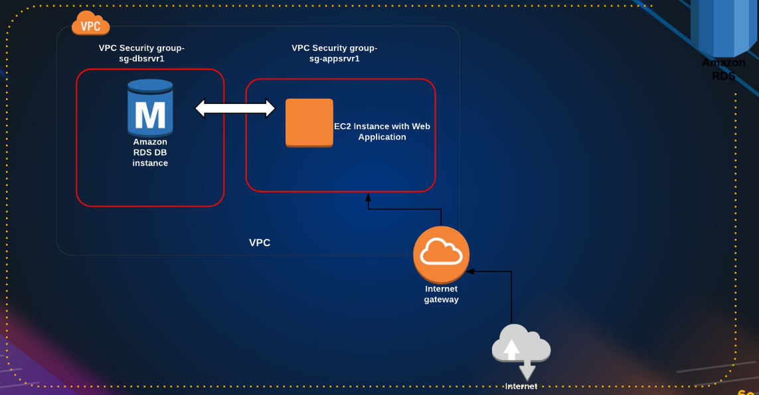

RDS 🡪create a db (eg: mysql)🡪create instance EC2🡪login to instances 🡪make sure SG have proper roles🡪 connect the db

Sudo yum install mariadb-server -y

If it not found the search for available server

sudo yum/dnf search mariadb

and install it

to connect the server: mysql -h YourDatabaseEndpoint -u YourUsername -p current password

“””need to check for password reset”””

RDS cost’s more accounting to usage. Use properly

# Welcome to the RDS Session

Welcome to the RDS session, where we'll explore Amazon's Relational Database Service (RDS) and how it can significantly simplify database administration.

## The Challenges of Database Administration

Managing a database involves several complex tasks:

1. **Setting up the database:** Initial configuration and deployment.
2. **Regular patching:** Keeping the database software up-to-date.
3. **Continuous monitoring:** Ensuring performance and health.
4. **Performance tuning:** Optimizing database operations.
5. **Regular backups:** Ensuring data safety and availability for rollback in case of failures.
6. **Scaling:** Adjusting resources as business grows, which is challenging for SQL databases.
7. **Security:** Protecting data from unauthorized access.
8. **Hardware upgrades:** Managing physical resources.
9. **Storage management:** Scaling storage as needed.

## Introduction to AWS RDS

AWS RDS automates many of these tasks:

* **High Availability:** With Multi-AZ deployments, you can have a primary database and a standby replica in different availability zones. If the primary fails, the standby takes over.
* **Read Replicas:** For performance improvement, read replicas can handle read requests, reducing the load on the primary database.
* **Scalability:** Easy to scale databases and storage.
* **Security:** Integrated security features to protect your data.

## Setting Up an RDS Instance

### Step-by-Step Guide:

1. **Navigate to RDS:**
   * Go to the RDS section in your AWS Management Console.
2. **Choose Database Engine:**
   * Supports MySQL, PostgreSQL, Oracle, MariaDB, SQL Server, and Amazon Aurora.
   * For this demo, we'll use MySQL.
3. **Select the Database Configuration:**
   * Choose between Production, Dev/Test, and Free Tier templates.
   * For this demo, we’ll use the Dev/Test option.
4. **Configure Instance Details:**
   * Instance name: **vprofile-mysql-rds**
   * Login credentials: **admin** (password auto-generated for this demo).
   * Instance size: **t3.micro** for free tier eligibility.
   * Storage: General Purpose SSD, 20GB with auto-scaling enabled.
5. **Set Network and Security:**
   * VPC: Default
   * Subnet: Default
   * Public accessibility: No (private access within the VPC)
   * Security group: Create a new one named **vprofile-rds-sg**
6. **Database Options:**
   * Database name: **accounts**
   * Backup retention: 7 days
   * Enable encryption and enhanced monitoring (default settings)
7. **Launch the Database:**
   * Review settings and click **Create Database**.

### Accessing the RDS Instance

1. **Create an EC2 Instance in the Same VPC:**
   * Launch an Ubuntu 18.04 instance named **mysql-client**.
   * Ensure it’s in the same VPC as your RDS instance.
2. **Install MySQL Client:**
   * SSH into your EC2 instance.
   * Run **sudo apt update && sudo apt install mysql-client -y**.
3. **Connect to RDS:**
   * Use the RDS endpoint, username, and password to connect.
   * Command: **mysql -h <RDS_ENDPOINT> -u admin -p**

### Troubleshooting Connection Issues

* **Security Group Settings:**
  + Ensure the RDS security group allows inbound connections on port 3306 from your EC2 instance's security group.
* **Network Issues:**
  + Verify network connectivity using tools like **telnet**.

## RDS Features and Management

* **Automatic Backups and Snapshots:** RDS automatically backs up your database and creates snapshots, which can be restored if needed.
* **Read Replicas:** Create replicas for load balancing read traffic.
* **Parameter Groups:** Customize database parameters to optimize performance.

## Conclusion

AWS RDS automates many aspects of database management, reducing the need for a dedicated database administrator. It offers high availability, easy scalability, enhanced security, and regular backups, making it an ideal choice for businesses of all sizes.

**Remember:** Always clean up your resources after use to avoid unnecessary charges. Delete the RDS instance and any associated EC2 instances once you are done.

Thank you for joining this session. See you in the next one!

# Aws lift & shift project

🡪Refer the pdf in the devops learning

Vproject vagrant project shift to aws server

Vagrant:

User 🡪Nginx(load balancer🡪single end point) 🡪 Apache tomcat server(httpd servers)🡪 rabbit mq(message service)🡪Memcached(temporary che service) 🡪 database (mysql)

Vs

Aws

User 🡪 load balancer 🡪 instance (tomcat, RabbitMQ, Memcached,mysql instances)🡪key pairs 🡪 security group🡪s3/EFS🡪Rout 53

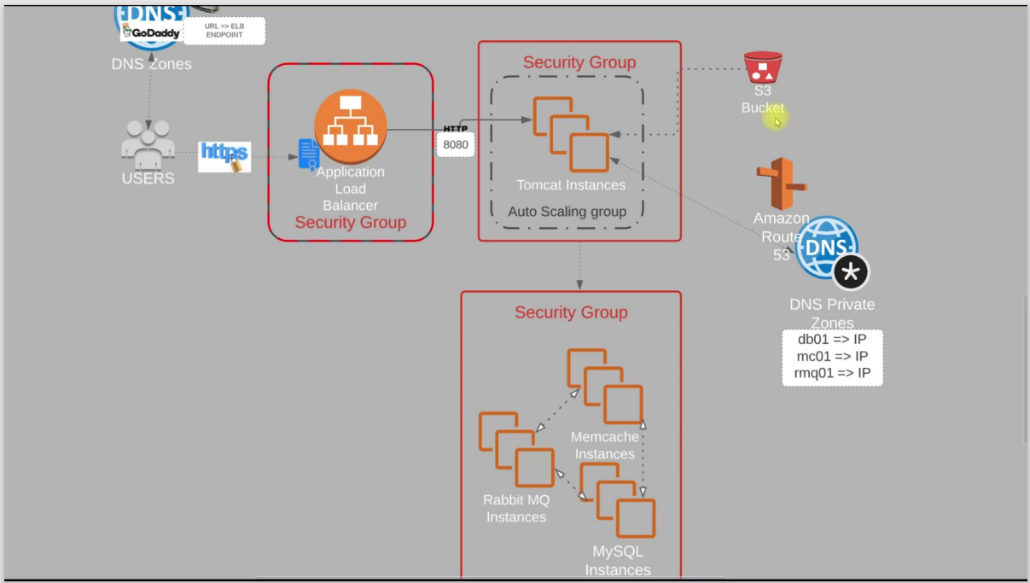

Key pair : bproject-KP.pem

Security group :

ELB: inbound roles http & https to 8080 port for 0.0.0.0/0 & ::/0

APP: inbound roles 8080 port / allow the elb-sg to app & port 22

BACKEND: here we are using three services : mysql, Memcached and rabbitmq

Allow every port app-sg 3306 for sql , 5672 for rabbitmq and memecached 11211 and allow same sg for internal data transfer.

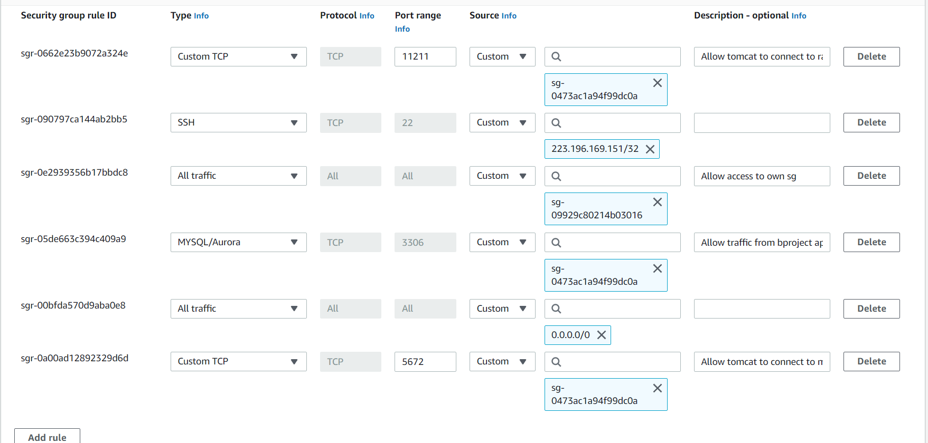

Then create ec2 for all 4 services mysql,rabbitmq,memecacahed & tomcat7(ubuntu)

By provision bash script in git repo aws lift and shift

“”default tomcat application can be they in this provision is /var/lib/tomcat9” we find webfiles here and inside ROOT(default tomcat page) will be there

<https://github.com/hkhcoder/vprofile-project/tree/main>

* Check the service active are not
* We can check the retrieve data for ec2 by curl <http://169.254.169.254/latest/user-data>
* We can check status by systemctl or ss -tunlp | grep “given the service port number”

Normally we use /etc/hosts to ip addr in vagrant but in ROUTE 53 service in aws

https://github.com/devopshydclub

# ROUTE 53

Domain name service (DNS)

# VPC (virtual private cloud)

At the early stage of AWS(cloud computing started), aws come up with SQS,S3, classic EC2 instance.

"We initially had data centers, and we still maintain them. In these data center networks, there are a multitude of components, including switches, routers, firewalls, and numerous interconnected networks. Within these networks, smaller subnets play a crucial role. A subnet serves as a dedicated portion of the network, often allocated for specific projects or front-end and back-end services associated with those projects. Security levels vary, with some subnets being highly restricted while others remain open to the internet.

Network access control lists (ACLs) come into play to determine what traffic can enter or exit, while IP addresses are meticulously planned as part of the network scheme. All of this falls under the jurisdiction of the networking team, responsible for designing and managing the networks in corporate data centers, whether they are vast or more compact in scale.

Then, a significant development occurred with the introduction of AWS's EC2 service, which revolutionized our capabilities. It allowed us to launch virtual machines within AWS or Amazon Data Centers for computing purposes. However, the demand for greater networking control grew. People wanted to customize their networking schemes and regulate inbound and outbound traffic according to their specific requirements. Unfortunately, these features were not initially available in the early versions of EC2.

In response to these demands, AWS introduced the VPC (Virtual Private Cloud), which provided the desired networking flexibility and control."

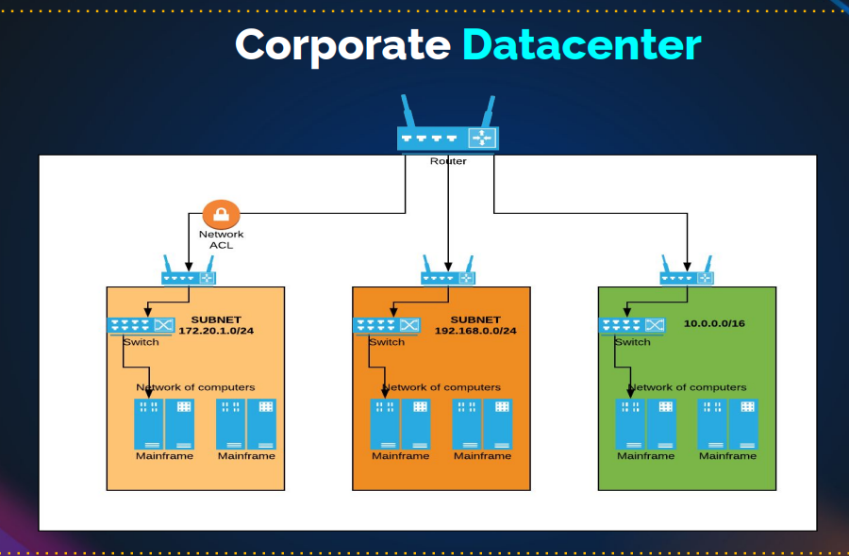

VPC:

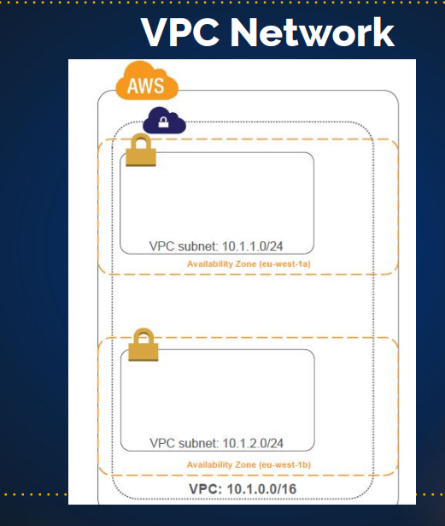

## Virtual Private Cloud (VPC)

1. VPC is a logical data center within an AWS Region.

Normally you have the default vpc but when created the VPC you have more control in it. You create instance, RDS etc inside VPC.

1. virtual private cloud is an on-demand configurable pool of shared computing resources allocated within a public cloud environment.
2. Control over network environment, select IP address range, subnets and configure route tables and gateways.

## IPv4 Address

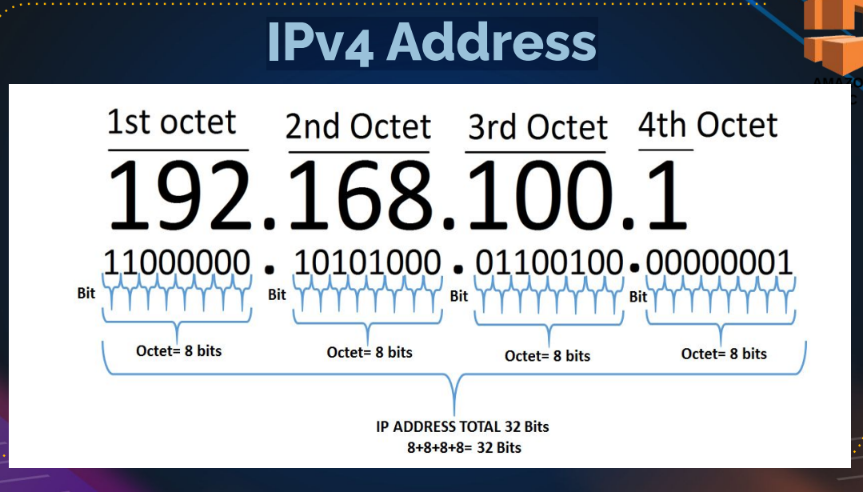

### IPv4 Range

1. 0.0.0.0 – 255.255.255.255

🡪 0000000.00000000.00000000.00000000 (0.0.0.0)

🡪11111111.11111111.11111111.11111111 (255.255.255.255)

### public and Private IP Division

* Public IP => Internet

• E:g 54.86.23.90

• Private IP => For local network design

• E:g 192.168.1.10

### Private IP Ranges

1. Class A 10.0.0.0 - 10.255.255.255
2. Class B 172.16.0.0 - 172.31.255.255
3. Class C 192.168.0.0 - 192.168.255.255

### Subnet Masks

● 255.0.0.0

● 255.255.0.0

● 255.255.255.0

A subnet mask is a 32-bit address that segments an IP address into network and host portions. It is used in networking to determine which part of an IP address identifies the network and which part identifies the specific host within that network. Subnet masks consist of a series of contiguous 1s followed by a series of contiguous 0s, with the 1s indicating the network portion and the 0s indicating the host portion.

For example, in the common IPv4 notation, a subnet mask might look like this:

* 255.255.255.0

In binary, this subnet mask would be represented as:

* 11111111.11111111.11111111.00000000

In this example, the first 24 bits (the 1s) are used to represent the network, while the last 8 bits (the 0s) are used to represent individual hosts within that network. This allows for the segmentation of IP addresses into different subnets, each with its own network and hosts.

Subnet masks are crucial in IP addressing and routing because they help routers and devices determine whether an IP address is on the same local network or if it needs to be forwarded to another network. By applying the subnet mask to an IP address, you can determine the network address and use that information for routing traffic within or between networks.

Subnetmask will decide on the network that an IP address

range starts at what IP, ends at what IP.

How many IP address do you get from the range?

What will be the network address?

What will be the broadcast address?

All these things are decided based on the subnet mask.

Top of Form

DSCP server will give the subnet mark and the network range

## Example

Your Ip address: 192.168.0.174

Subnet mark: 255.255.255.0

So

192.168.0.0 🡪 Network IP

192.168.0.1 🡪First usable IP

192.168.0.2

.

.

.

192.168.0.254 🡪 Last usable IP

192.168.0.255 🡪 broadcast

TOTAL IP : 256

TOTAL USABLE IP : 254

Your Ip address: 172.16.12.16

Subnet mark: 255.255.0.0

So

172.16.0.0 🡪 Network IP

172.16.0.1 🡪 Last Usable IP

172.16.0.2

.

.

.

172.16.0.255

172.16.1.0

172.16.1.1

.

.

.

172.16.255.254 🡪 Last usable IP

172.16.255.255 🡪 Broadcast IP

TOTAL IP : 256*256

TOTAL USABLE IP : 256*256 -2

Your Ip address: 10.23.12.56

Subnet mark: 255.0.0.0

SO

10.0.0.0/8 🡪 /24 is notation in cloud completed representation of subnet mask

10.1.0.0/24

10.2.0.0/24

.

.

10.255.0.0/24

10.255.1.0/24

10.255.2.0/24

.

.

.

10.255.255.254/24

10.255.255.255/24

TOTAL IP : 256*256*256

TOTAL USABLE IP : 256*256 *256-2

## **CIDR** - Classless Inter-Domain Routing

Subnet mask

255.255.255.0

11111111. 11111111. 11111111.00000000

CIDR notation 🡪 /24

255.255.0.0

11111111. 11111111. 00000000. 00000000

CIDR notation 🡪 /16

255.255.0.0

11111111.00000000.00000000.00000000

CIDR notation 🡪 /8

Note **: also we have online subnet calculators**

# VPC design and components

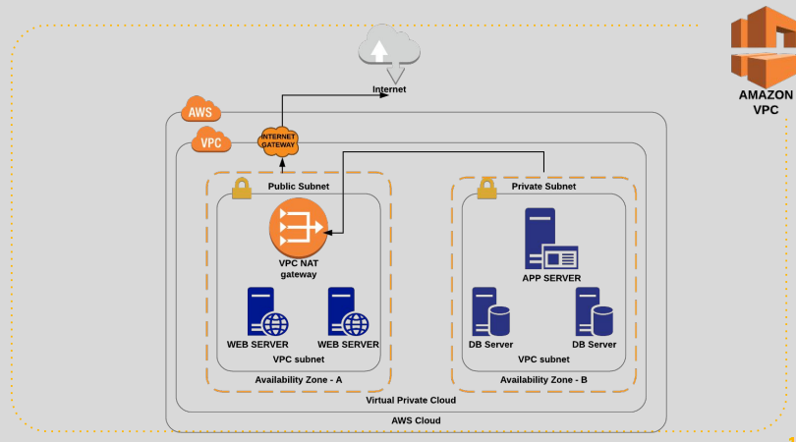

This is basic VPC, they two kinds of subnet in VPC ( public & private ).

* PUBLIC SUBNET can access the internet directly thought internet gateway (it will manage interner though and flow).
* private subnet can’t access directly, first it will route to public subnet though NAT gateway(NAT gateway act as wi-fi router and connected to the internet).

Network Address Translation (NAT) gateway to enable instances in a private subnet to connect to the internet or other AWS services.

An internet gateway is a horizontally scaled, redundant, and highly available VPC component that allows communication between instances in your VPC and the internet.

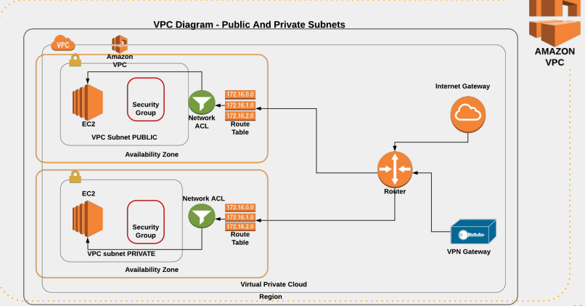

In the above design , route table decide the network connect need to go to Nat gateway or internet gateway

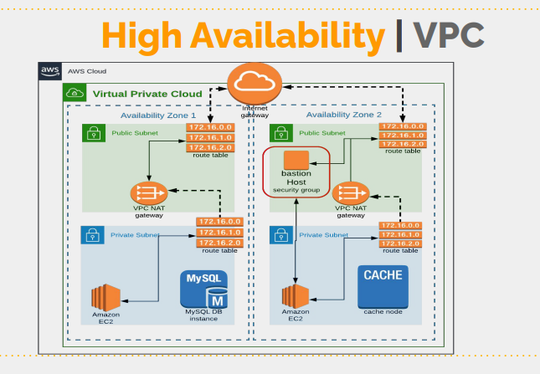

In this we have deploy the instances in two AZ’S for the high availability and set the 2 NAT gateway(only nat gateway is chargeable in above diagram)

See the above design and understand it

# VPC SETUP DETIALS

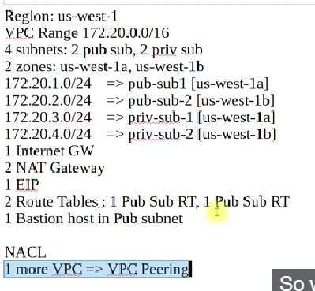

# Default VPC

Normally, a default VPC is create in AWS. and we can’t create a default VPC. (We can create VPC but can’t make it default)

Similarly, in subnets also they are two default public subnet will be they

If you need find subnet are public or private

Select any subnet 🡪 route table (check port connection whether it is connecting to internet gateway or NAT gateway)

## Note

Don’t delete default VPC, internet gateways or route table. (if you delete you need to reach AWS helpdesk)

# Create VPC

Nat gateway is expensive

## VPC and more

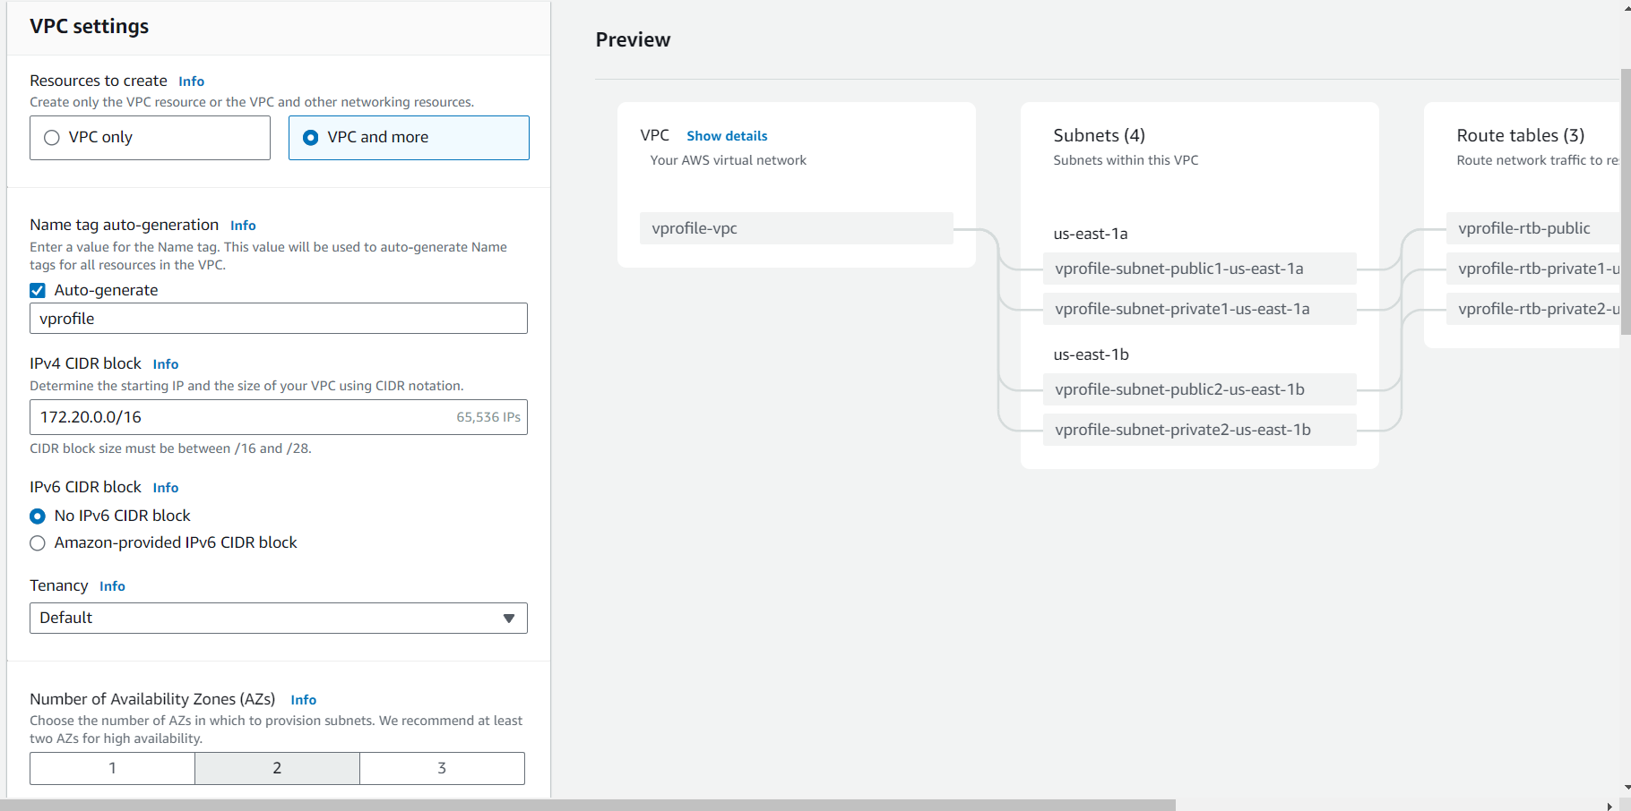

It will create the all compounds (subnet, route table & network connection)

But in this class we going to create by individually

## VPC only

In create 4 subnets (2 for public, 2 for private)

Vpro-pubsub-1 172.20.1.0/24 us-west-1a

Vpro-pubsub-2 172.20.2.0/24 us-west-1b

Vpro-pubsub-1 172.20.3.0/24 us-west-1a

Vpro-pubsub-2 172.20.4.0/24 us-west-1b

# INTERNET GATEWAY

Internet gateway 🡪 create internet gateway

Attach internet gateway to vpc(vprofile)

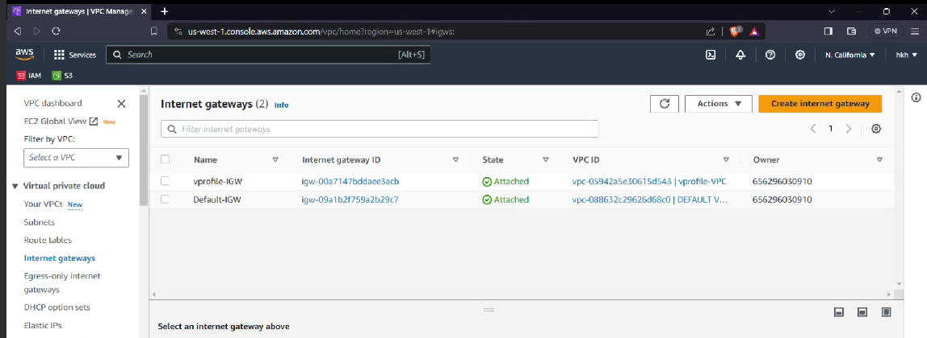

# Route Table

When you create a VPC, it automatically create one route table

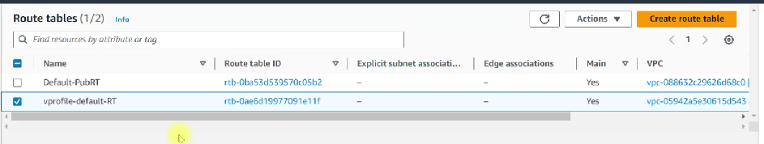

But create a new route table and add the public subnets and edit route add 0.0.0.0/0 🡪 this makes it public

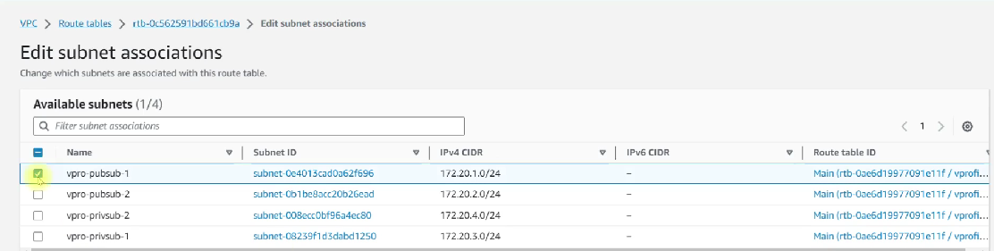

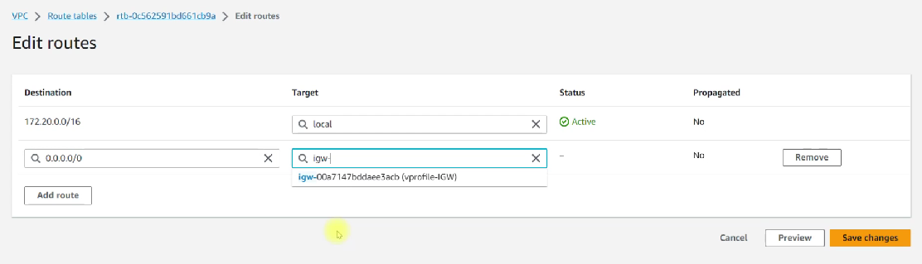

# NAT Gateway

* First create Elastic IP

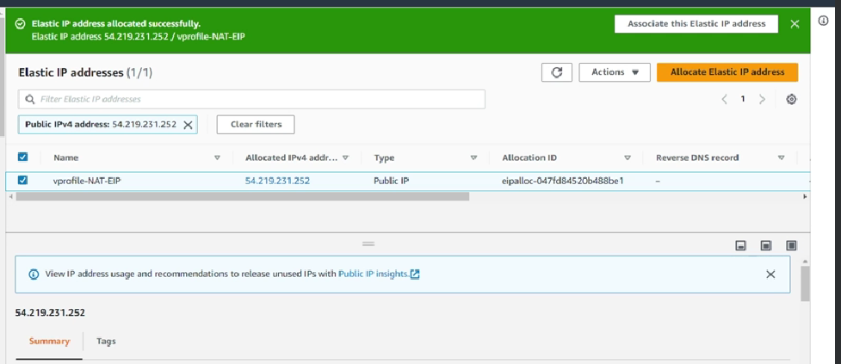

* Create a nat gateway

Nat gateway is connected to private subnets but it lives in public subnet(place in pubsub)

Add the allocated elastic IP which we created before

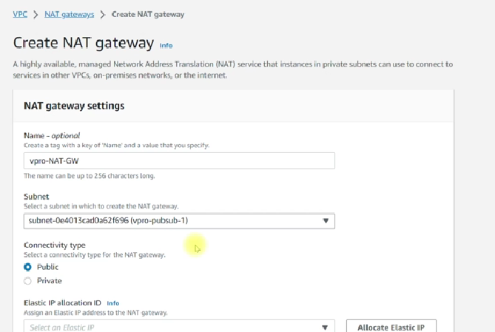

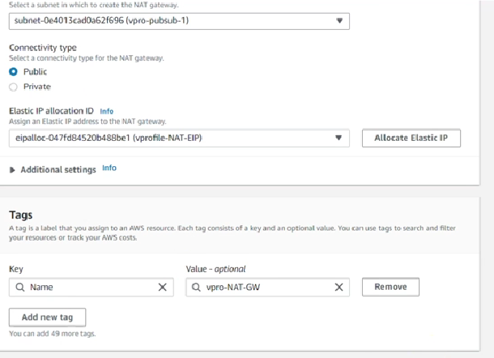

In meantime

* Create a route table for private IP

Create route table(vprofile-priv-RT)🡪 attach to vprofile-vpc

route table(vprofile-priv-RT)🡪subnets associations 🡪 edit subnets associations 🡪 add the private subnets 🡪 save associations

route table(vprofile-priv-RT)🡪 route 🡪 add the route 0.0.0.0/0 🡪 nat gateway

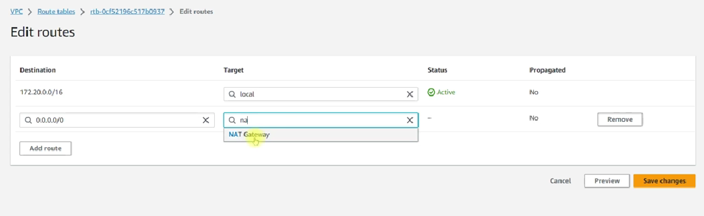

## Host names

We can enable the host names (but it not a default),

Goto VPC🡪find your VPC(vprofile)🡪 Action🡪 edit VPC setting🡪enable DNS Host names

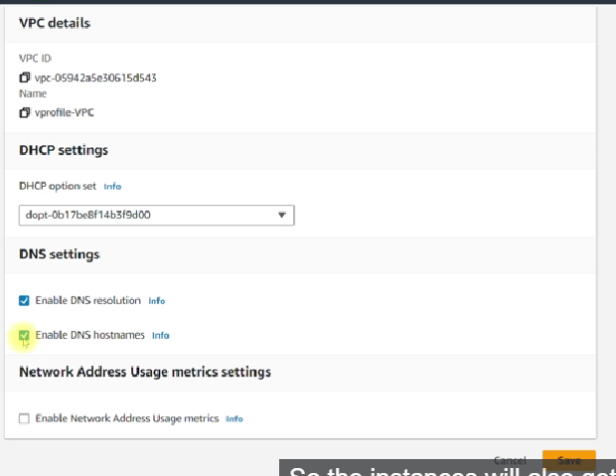

# Bastion host/Jump server

Jump server 🡪it is not a VPC team, it is general networking term assigned to any secure network, host or computer through which you can access the private subnet or resources in the private subnet.

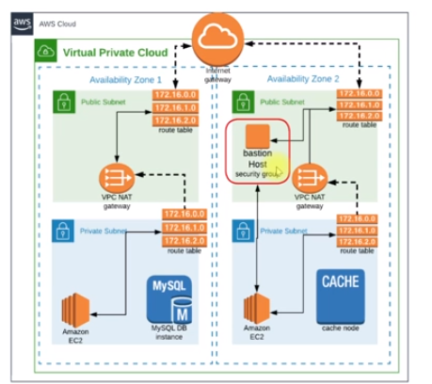

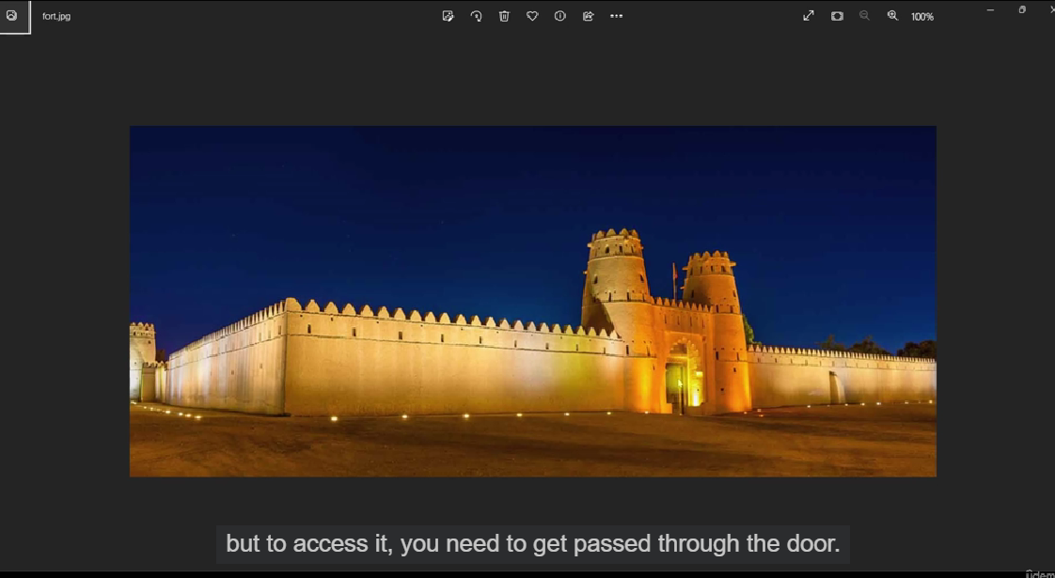

Create a security group:

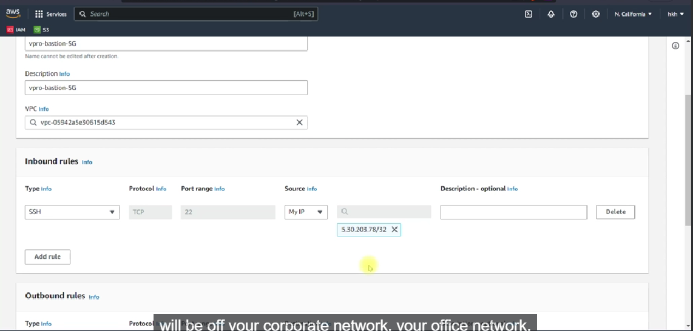

Create a key-pair

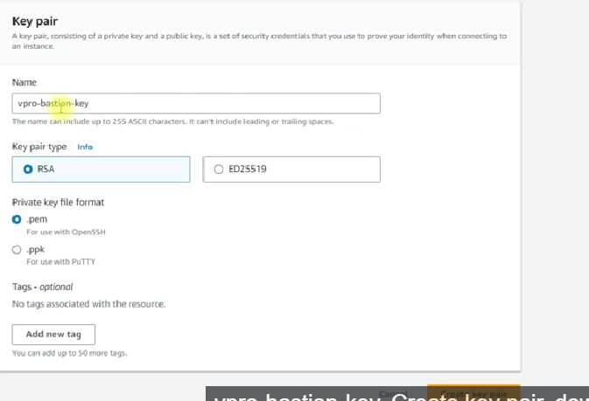

AMI:

So far we are using the free AMI, **But for the real time (bastion host), you should go for AMI that as tested for vulnerability 🡪 ex : CIS (central security information system)**

* **Create a ubuntu instances for this**

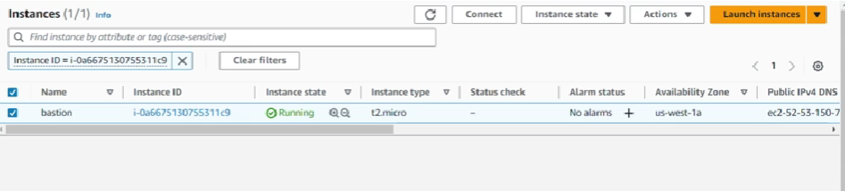

# Website in VPC